**What's new in Dynamics 365 Business Central telemetry - November 2022**

It is November and it as been a month since the last newsletter. As I wrote last time, the bleeding edge news on Dynamics 365 Business Central telemetry happens on Twitter, so if you want to keep up with the latest and greatest (and the beta versions of the Power BI telemetry apps) then follow me there (@kennienp). The intention of these monthly newsletters is to try to gather everything that I know in this area and present it here. Let’s go…

# Get alerts when something happens

I will start with a story about a trend that I see forming in our partner community: getting proactive with alerting on telemetry. To me this is a sign that the telemetry maturity model is being picked up by front runner partners that are now relatively comfortable with using the easy-to-get insights from the Power BI apps on telemetry. They can see the impact of this in their businesses and now they are ready to harvest the next benefits of telemetry.

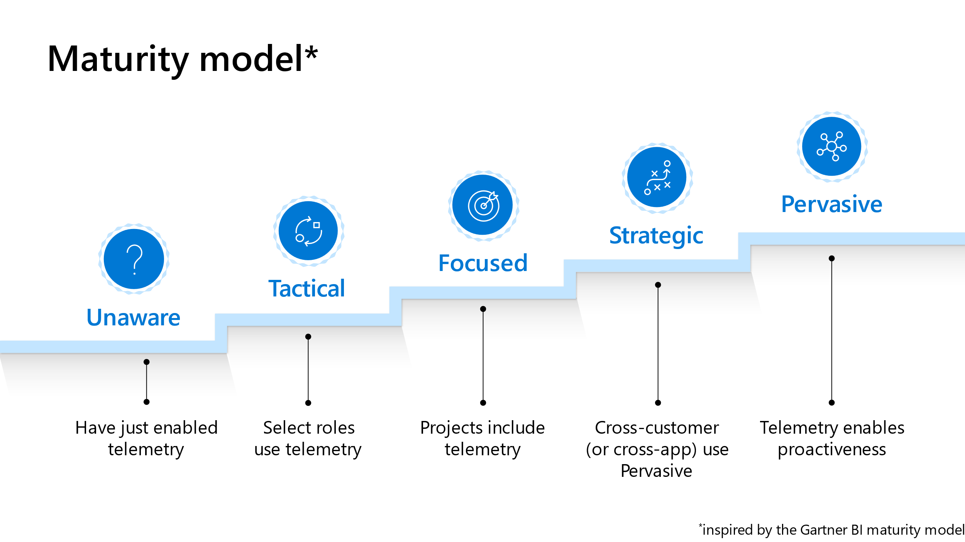

If you want to dive further into the model and how to use it to get more data-driven, please go to the BCtech repo here

<https://github.com/microsoft/BCTech/tree/master/samples/AppInsights/Presentations>

and download the Powerpoint deck Using telemetry to improve your partner practices and processes.pptx

The deck has introductions to the different levels in the model as well as ways for you to assess where you currently are and suggestions for quick wins that can help you get to the next level(s).

In the model, alerting is introduced on level 5, but you can of course start with alerting anytime you want.

So, what is alerting all about? We have defined alerting this way in docs

*If something happens in your environment or app that you need to take action on, you might want to have a system that sends you an alert.*

Note that the definition does not state whether that *something* is good or bad.

Examples of good things are

* Someone just installed our app from appsource
* Someone started using feature XYZ
* An environment was successfully upgraded
* A new version of Business Central is ready

Examples of bad things are

* We regressed in performance when we released the new version of our app
* An environment could not install/update our app
* User login failures are higher than the threshold we have setup
* Some job queues are failing

When you read through all these examples, did you notice something? They are all formulated like *Something happened*. But sometimes, you would like to know if there is absence of signal.

Here are some examples of absence of signal

* Job queues are not running
* No new sessions have been created the last x hours

When defining an alert based on telemetry, you need to define two things:

1. A Kusto (KQL) query that defines the alerting condition.
2. How often you want to run the alerting query.

To make it easier for you to get started, we added some sample KQL queries to the BCTech repository as well as a description of the alerting scenarios (why would you want to alert on this):

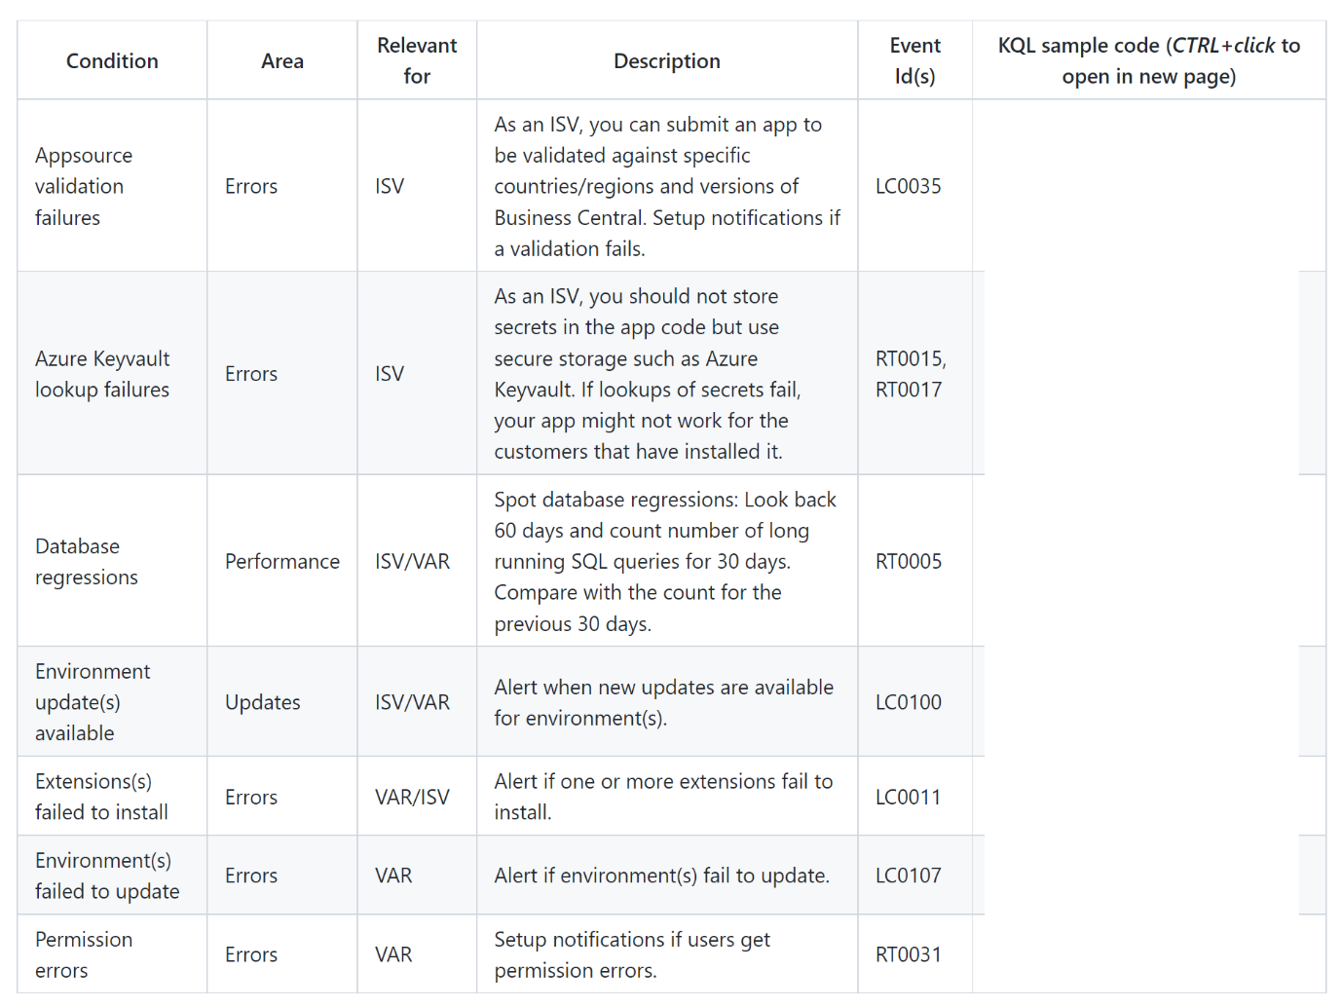

Go check out the live list here:

<https://github.com/microsoft/BCTech/tree/master/samples/AppInsights/Alerts#alerting-condition-kql-samples>

But how do you setup alerting and which channels can you get alerts/notifications in?

Well, there are at least three different tools that I know of

* Directly in the Azure Application Insights portal on Azure,
* Azure Logic Apps, or
* Power Automate

With respect to channels, only your imagination is the limit here (at least when using Logic apps):

* Text messages
* Email
* Teams channel messages
* Azure Devops
* …

Azure Logic Apps and Power Automate have built-in connectors to query telemetry in Application Insights that you can use to set up custom notifications or to automate certain actions triggered by an environment lifecycle event. What I hear when talking to partners, Logic Apps is currently the tool of choice. To help you get started really quickly, we therefore added click-clickety-click samples directly in docs. Go check them out here

<https://learn.microsoft.com/en-us/dynamics365/business-central/dev-itpro/administration/telemetry-overview#example---run-an-alerting-query-every-n-days-and-send-an-email>

and setup your first alert today. Choose an alerting scenario that you think will save your organization time and money (get the alerting KQL sample from the BCTech repo as mentioned above).

Read all about alerting here in our documentation

<https://learn.microsoft.com/en-us/dynamics365/business-central/dev-itpro/administration/telemetry-overview#setting-up-alerts-on-telemetry-events>

# Feedback on how a partner is using telemetry (for inspiration)

Recently, I got some feedback from a partner who use telemetry to get more productive. I thought it could be useful to share some of their use cases to a broader audience, so here goes…

"The app has been extremely useful, as the customer (government) is hesitant to give access to Application Insights, but has been willing to share the app reports"

Kennie says: If you want to do the same, learn more on how to do this here:

<https://learn.microsoft.com/en-us/dynamics365/business-central/dev-itpro/administration/telemetry-power-bi-app#share-the-app-with-coworkers-and-others:~:text=enter%20it%20again.-,Share%20the%20app%20with%20coworkers%20and%20others,-Once%20installed%2C%20it%27s>

"The ability to quickly correlate #msdyn365bc hotfix rollouts with

a) the interruption of a long-running process, and

b) the introduction of a base app bug

saved us a lot of time in a couple of critical cases."

Kennie says: If you want to do the same, go to the Environment Changes in the Administration report:

"The ability to quickly survey web service usage has been valuable in terms of assessing our integrations' impact on performance."

Kennie says: If you want to do the same, go to the Web Service Performance (incoming/outgoing) page in the Performance report.

"The areas identified as performance issues in the app correspond with our client's reported performance issues, which gives us confidence that we're digging in the right areas."

Kennie says: Use data (not guesses) to prove where performance issues come from… 😊

# Telemetry sessions at Directions EMEA 2022

This year at the Directions EMEA 2022 conference, you can learn about telemetry in quite a few sessions.

**Extending Telemetry With Power Platform: Power Pages You're Welcome**

Telemetry and its application is being adopted by more and more Partners. But are we using and unfolding its full potential? In this session we'll be able to see that the practical applications and information provided by telemetry can be supported and benefit from everything that the Power Platform offers us.From processing information in Power BI, automating usage scenarios or distributing and communicating actions and alerts in Power Pages to internal teams.Do you want to learn more? Join us in this session!!

<https://directions4partners.com/events/directions-emea-2022/session-schedule?tid=373052>

**Guess less. Sell more.**

Learn how you can use telemetry to plan better follow-up meetings with your customers. Instead of asking the customer how it is going, use telemetry to know their pain and where they can get more value out of their investments. Bring value to the next follow-up meeting and bring in more sales because the customer feels that you know their business. The session is mainly for people working with selling Business Central.

<https://directions4partners.com/events/directions-emea-2022/session-schedule?tid=386687>

**Microsoft Workshop: Hands-On Lab About Telemetry**

Want to get started with telemetry and the many capabilities it unlocks? Do you find it hard to get started? Then come to this workshop and get unblocked. Bring a laptop and have telemetry enabled on ono or more environments or apps prior to the workshop. If you also have a Power BI pro license, you can get really far. In the workshop, telemetry experts from Microsoft and the community will be available to help you get unblocked with whatever you find difficult.

<https://directions4partners.com/events/directions-emea-2022/session-schedule?tid=388539>

**BC Telemetry Activated, Now What? Practical Examples For Analyzing, Monitoring And Alerting**

Telemetry signals are here, Power BI telemetry app is easily accessible for everyone, now what? How do you analyze data, how do you decide what's important, who's monitoring telemetry data and what do you do with it? We have monitored and analyzed data for BC Partners and now gathered practical examples and recurring reports to share what you should be monitoring and what to do with it. In this session I will show how to spend your time wisely with telemetry and become more proactive with your customer issues with alerts, budgeting and routine reports.

I will also share our Partner telemetry usage survey results during the session.

<https://directions4partners.com/events/directions-emea-2022/session-schedule?tid=369782>

**Advanced And Proactive Monitoring Of A Dynamics 365 Business Central Tenant**

Everyone knows that Dynamics 365 Business Central can redirect its telemetries to Azure Application Insights. This means that you can monitor what happens under the hood of your tenant and you can discover problems. But applying the standard telemetry practices could sometimes not be enough in a real world scenario.

How can you react on problems? How can you be proactive on receiving telemetry data without using the Azure Portal? How can you monitor multiple customers at once? How can you establish a telemetry practice that rocks?

In this session we'll see how you can enhance your Dynamics 365 Business Central tenant's monitoring experience by extending the standard Business Central monitoring features with new services that you can apply in your real-world projects.

<https://directions4partners.com/events/directions-emea-2022/session-schedule?tid=360369>

**Microsoft Presents: What's New In Environment Administration?**

In this session, we will discuss and demo some of the new features in environment administration, including Service-to-Service Authentication for the Admin Center API, environment lifecycle telemetry in AppInsights, improved update scheduling functionality, and cloud migration.

<https://directions4partners.com/events/directions-emea-2022/session-schedule?tid=387288>

# New recordings about telemetry

**Office hours call on 'Get data-driven with Telemetry'**

On October 4, 2022, we did an office hours call with the title 'Get data-driven with Telemetry' and this abstract:

*In this office hours call; we will discuss how to use telemetry to change your business processes as a reseller/ISV partner. In particular, we will present the new Power BI app on telemetry and present usage scenarios for account managers, project managers, functional consultants, product owners, and support engineers. We will discuss ways to keep telemetry cost under control. And you, of course, have the opportunity to ask questions!*

You can find on-demand recordings of the office hours calls on [https://aka.ms/BCOfficeHoursRecordings](https://nam06.safelinks.protection.outlook.com/?url=https%3A%2F%2Faka.ms%2FBCOfficeHoursRecordings&data=05%7C01%7Cv-dneuhaus%40microsoft.com%7Ccc03349571254b7aece608da544a13f7%7C72f988bf86f141af91ab2d7cd011db47%7C1%7C0%7C637914974391495860%7CUnknown%7CTWFpbGZsb3d8eyJWIjoiMC4wLjAwMDAiLCJQIjoiV2luMzIiLCJBTiI6Ik1haWwiLCJXVCI6Mn0%3D%7C3000%7C%7C%7C&sdata=Oe7Acc6nWpiultFjtlFtQGWxuAihimKpb8h762Cqd9w%3D&reserved=0).

**Business Central Launch Event**

Didn't watch all the Business Central Launch Event recordings yet? Don't worry! You can still watch them on the event portal until end of January 2023.

For this semester, we did a session called Whats new in Telemetry, where you (among other things) can learn about the telemetry maturity model

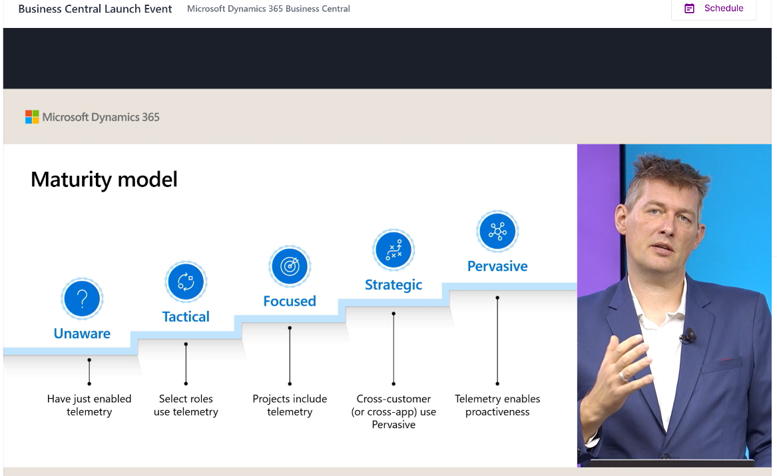

Find all sessions here: https://aka.ms/BCLE

# Updates to the Power BI apps on telemetry data

If you already use the (free and open source) Power BI apps on telemetry, please consider rating them on Appsource:

* <https://aka.ms/bctelemetryreport> (per-environment telemetry for VARs)
* <https://aka.ms/bctelemetry-isv-app> (per-app telemetry for ISVs)

If you are still new to the topic, start here

<https://learn.microsoft.com/en-us/dynamics365/business-central/dev-itpro/administration/telemetry-power-bi-app>

**Power BI apps on per-environment telemetry data (for VARs)**

Below, I will highlight some of the more prominent changes in the latest update(s) in the app on per-environment telemetry data (for VARs).

* The app now has added support for defining an include list of environments. This is important for partners who collect data from multiple customers into the same Application Insights resource, because they can now setup specific Power BI apps per customer and then share these apps with customers without the fear of sharing telemetry across customers.

Set this up using a parameter:

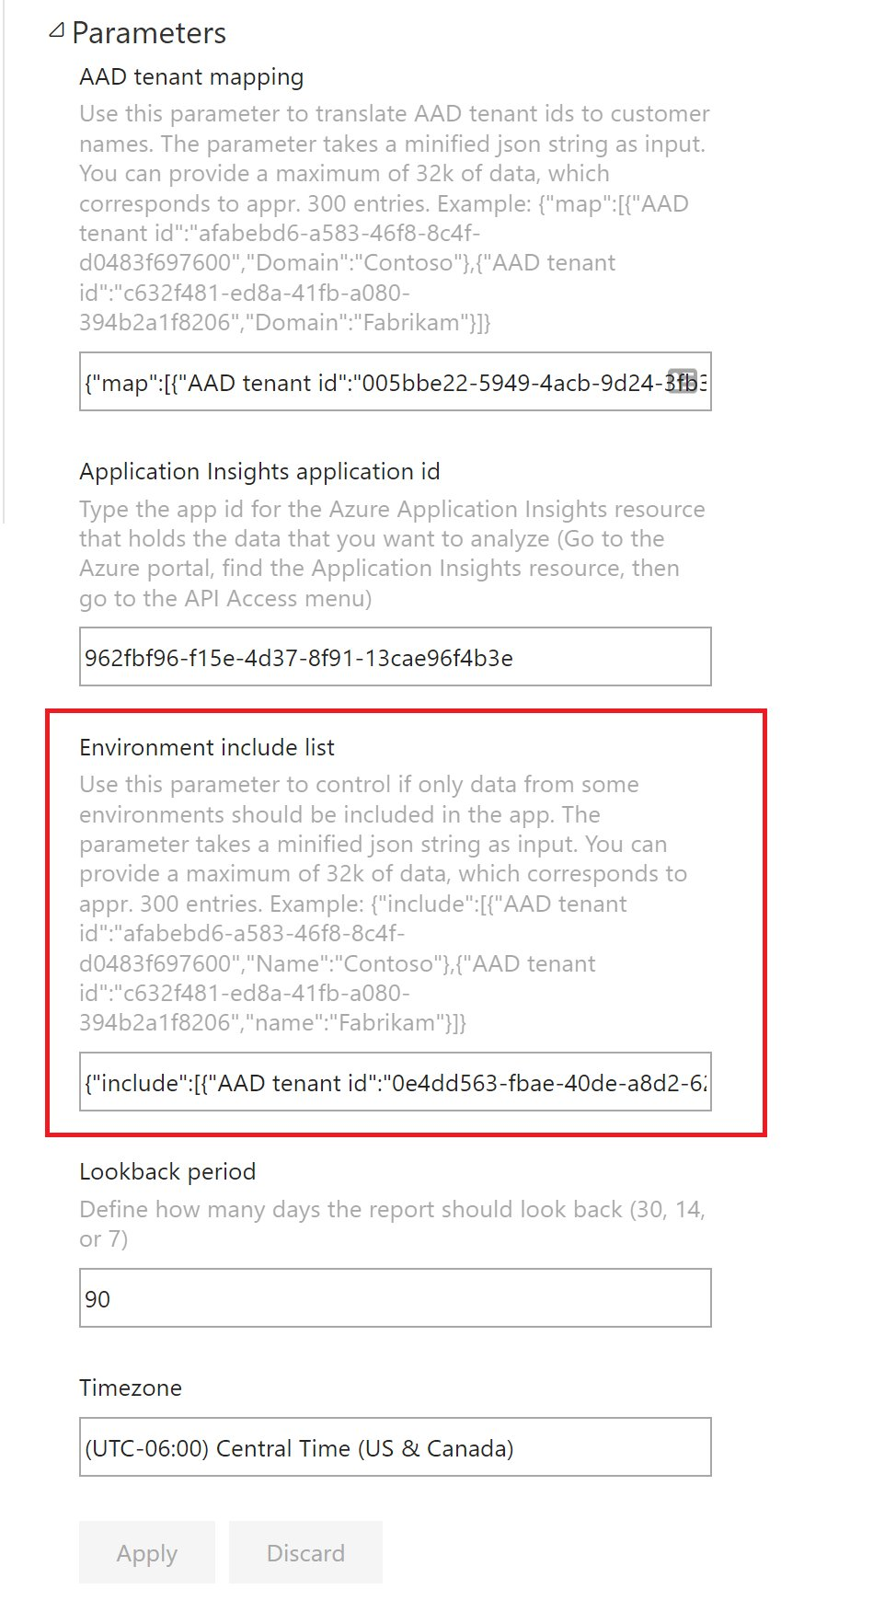

* New page Application Areas in the Usage report: Shows how a customer is using Business Central by main (base app) application areas.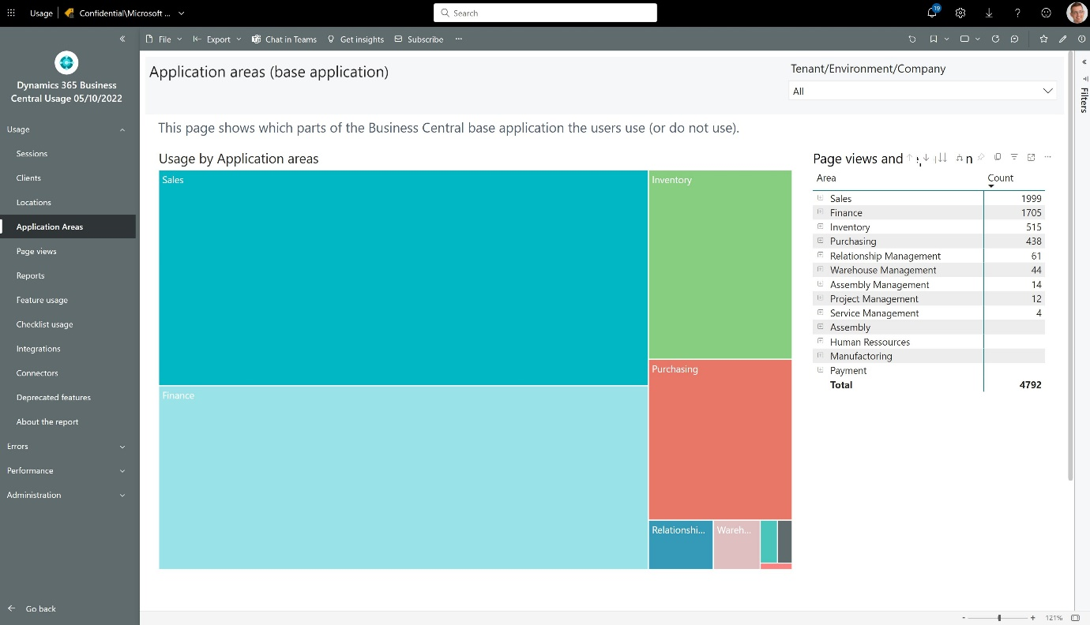
* Added new visuals to the locations page: Allows you to see which environments are being used in which locations. And when it happens
* New capabilities in the performance reports for long running SQL, long running AL, and lock timeouts pages: see the top/bottom of the call stack. The top shows where the problem is, the bottom shows where it shows up for the user.
* New fields on the Long running SQL page: ability to find queries that takes locks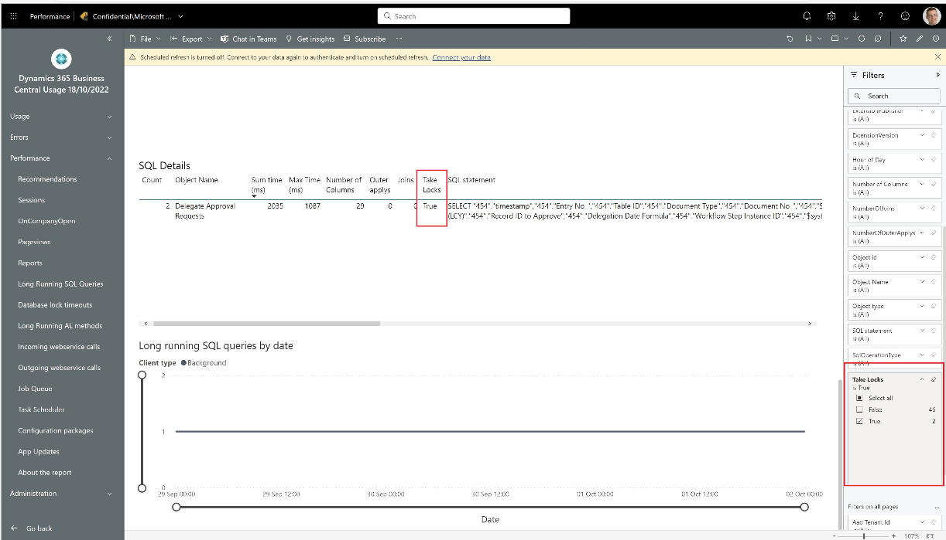
* Administration report: New page 'Configuration' to show how the app has been configured. Makes it easier to troubleshoot how Power BI app parameters affect the data load.

You can always find the full change log here:

<https://github.com/microsoft/BCTech/blob/master/samples/AppInsights/PowerBI/Reports/AppSource/environment-app-pbix/changelog.txt>

**Power BI apps on per-app telemetry data (for ISVs)**

Below, I will highlight some of the more prominent changes in the latest update(s) in the app on per-environment telemetry data (for VARs).

These changes will surface within the next few days:

* Administration, Extension lifecycle page: Added per-environment visual to make it easy to see changes across all customers using your app.
* Administration, Upgrade flow page: Added per-app visual to see upgrade flows across all your apps.
* Administration, app source validation page: added failure reason visual to make it easy to find the root cause for failed appsource validations. Also makes it possible to analyze which types of errors you typically have in your submissions over time.
* Administration report: New page 'Configuration' to show how the app has been configured. Makes it easier to troubleshoot how Power BI app parameters affect the data load.
* Changed order of top page filters to Publisher / App Name / App Id / Version (on Administration report). Seems to be a more natural way to drill down in data.
* Performance: on pages 'Long running SQL', and 'Long running AL' added visual with info on top/bottom line of the AL stack trace. The top shows where the problem is, the bottom shows where it shows up for the user.
* Performance: on page 'Long running SQL', added 'Take locks column' to make it easier to find long running queries that takes locks.
* Performance: on page 'Updates', added SQL row to SQL statement ratio to make it easy to find candidates for using the new AL feature Data Transfer for speeding up upgrades.

You can always find the full change log here:

<https://github.com/microsoft/BCTech/blob/master/samples/AppInsights/PowerBI/Reports/AppSource/isv-app-pbix/changelog-isv-app.txt>

# Who did what when?

If you would like to get a visual representation of what all sessions are doing in a slice of time, try this:

1. Take the new KQL sample query WhoDidWhatWhen.kql (<https://github.com/microsoft/BCTech/blob/master/samples/AppInsights/KQL/Queries/HelperQueries/WhoDidWhatWhen.kql>)
2. copy the result set into Excel
3. apply conditional formatting (just choose standard Color Scales

Now you can see who did what when…

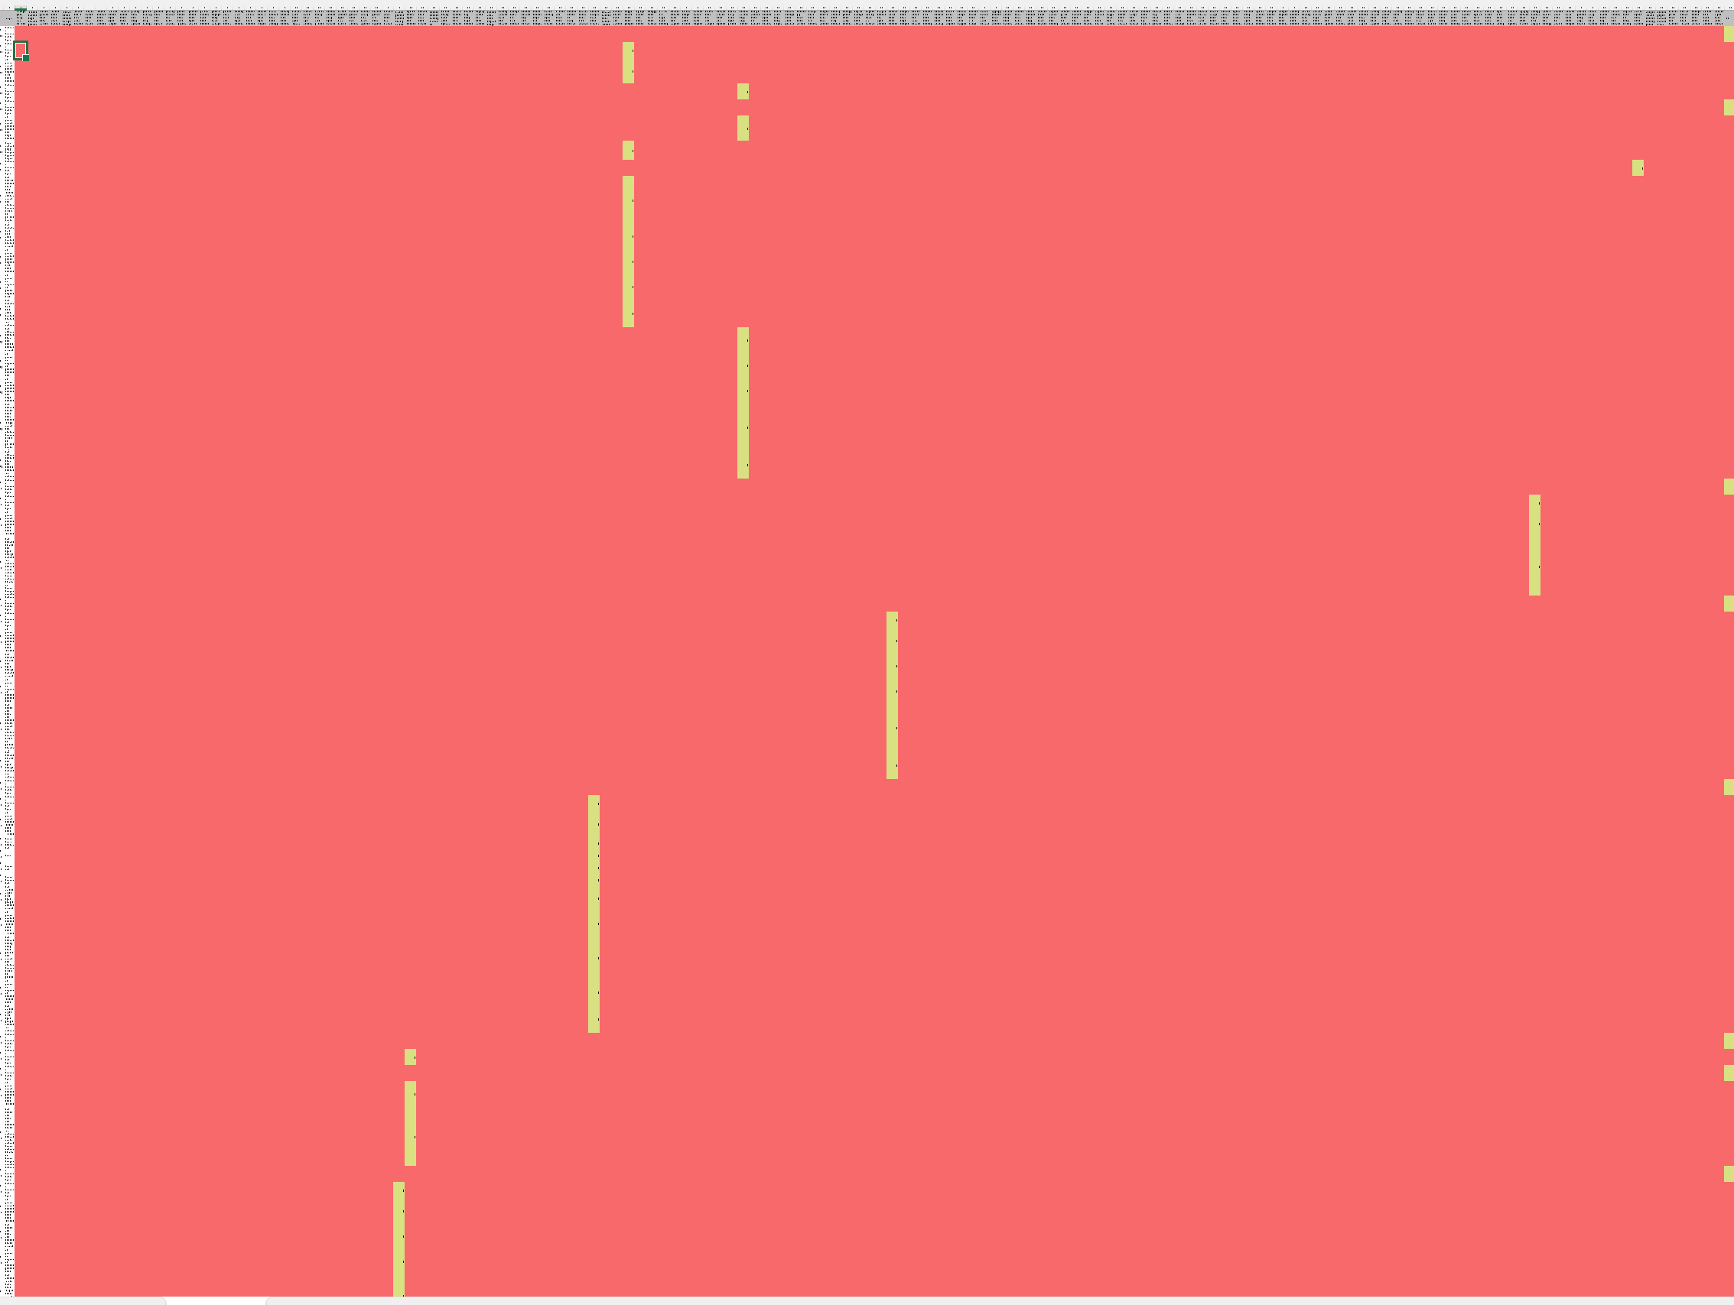

# New KQL samples

We also added some new KQL samples for the real telemetry geeks (you know who you are):

* The sample query for Long Running SQL now has a predicate that tells you if the query takes locks (<https://github.com/microsoft/BCTech/blob/master/samples/AppInsights/KQL/Queries/ExampleQueriesForEachArea/LongRunningSQLQueries.kql>)
* If you need to map client type info to session type (UI, WS, or Background) in queries, then use the new helper query snippet ClientTypeToSessionTypeMapping.kql (https://github.com/microsoft/BCTech/blob/master/samples/AppInsights/KQL/Queries/HelperQueries/ClientTypeToSessionTypeMapping.kql)
* Use the new KQL sample snippet parseStackTrace.kql to parse the top/bottom of the AL stack trace (<https://github.com/microsoft/BCTech/blob/master/samples/AppInsights/KQL/Queries/HelperQueries/parseStackTrace.kql> )

Thats it folk! Let me know in the comments if you want some specific topics covered in the newsletter. Stay tuned.